2011 Breeding Plans for Jacobs
JM Farm Sarah  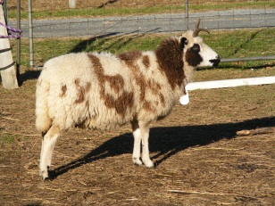 | Unzicker Mel  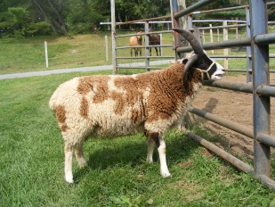 | 4 horns likely. Should show good markings and color. Nice fleece combination.
JM Farm Rebecca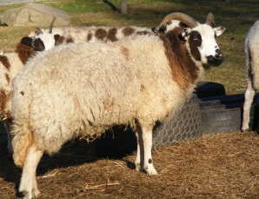 | Unzicker Mel | 4 horns possible. Hoping for more color than on the ewe. Should be a nice fleece.
JM Farm Deborah  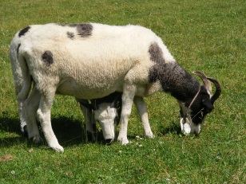 | JM Farm Benjamin  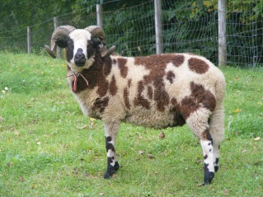 | Ewe bred to his father last fall. Retained ewe lamb. Hoping for better fleece with this combination.
JM Farm Naomi  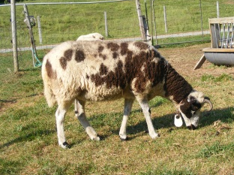 | JM Farm Benjamin | Ewe missed a season. Lasseau on both sides of this breeding. Hoping for a good fleece and good strong horns.
JM Farm Joanna  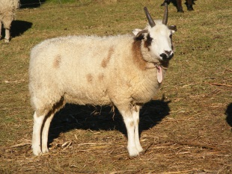 | JM Farm Benjamin | Ewe missed a season. Lasseau on both sides of this breeding. Hoping for a good fleece and better color.
JM Farm Bethany  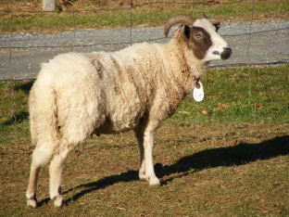 | JM Farm Benjamin | Repeat breeding. Retained ram lamb. Nice handle to fleece and good 2 horned head.

2011 Breeding Plans for Jacobs pg.2
JM Farm Magdelene  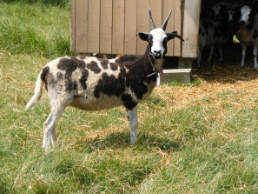 | Unzicker Mel | 4 horns likely. Looking for good fleece with decent staple and even markings.
Maple Hill Lia  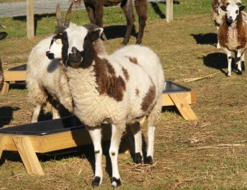 | JM Farm Benjamin | Ewe bred to his father last fall. Retained ewe lamb. 2 horns likely. Looking for good fleece with moderate coloring.
Maple Hill Nora  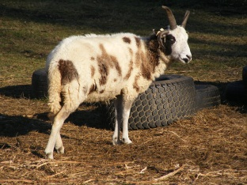 | JM Farm Benjamin | Ewe bred to his father last fall. Retained ewe lamb. 4 horns possible. Looking for good fleece with no quilting and good markings.
JM Farm Jamisen  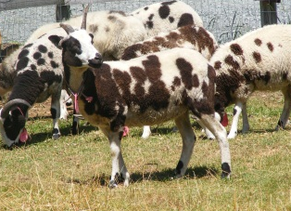 | Unzicker Mel | First time breeder. Multiple horns likely. Both have very good fleeces and markings.
JM Farm Delilah  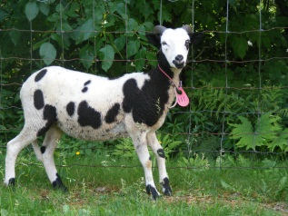 | JM Farm Benjamin | First time breeder. Looking to improve the markings and a decent fleece. 2 horns likely. Lasseau on both sides of this breeding.
JM Farm Abigail  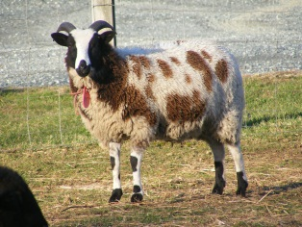 | Unzicker Mel | First time breeder. Looking to correct freckling in the fleece. Ram shows no freckling. Both have good fleeces.

2011 Breeding Plans for Jacobs pg.3
JM Farm Elizabeth  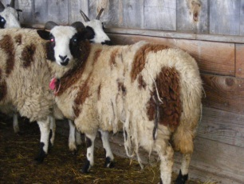 | Unzicker Mel | First time breeder. Ewe has very good fleece with long staple. Hoping to correct horns—a little narrow.
Gadzinski’s Dora  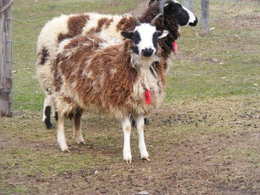 | Unzicker Mel | First time breeder. Ewe has a very open fleece. 4 horns likely.

